Steps to up the application

Step 1: import “projectmanager-parent” and set up db in your local, up the application in your local.

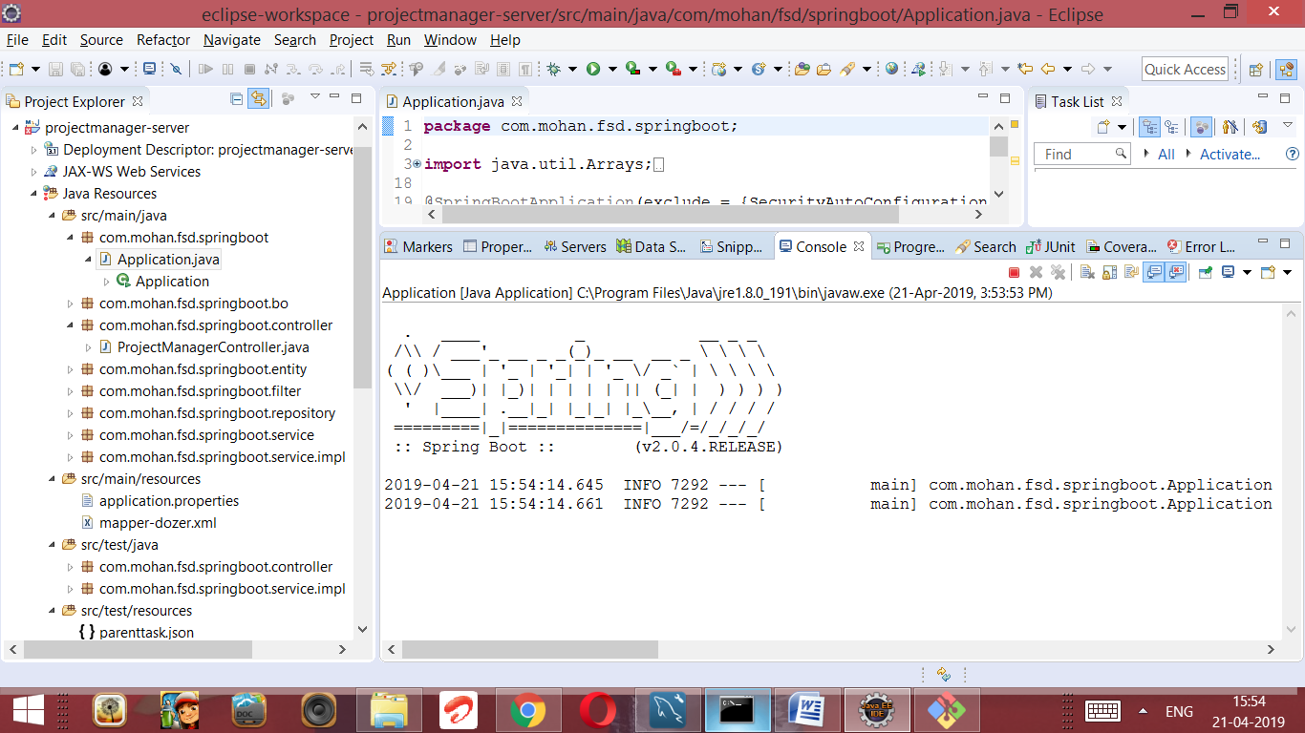

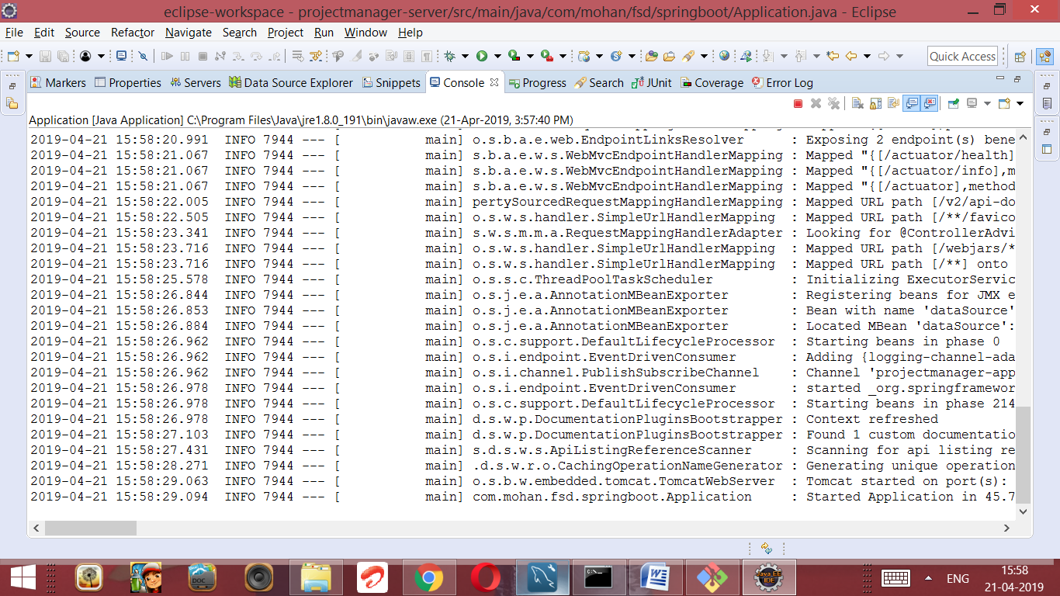

Step 2: go to cmd and open the web folder( projectmanager-parent\projectmanager-web\src\main\web), run as npm start once application up and run it will available in [http://localhost:4200](http://localhost:4200/)

